Matthew Cournoyer, Kristin DeMatteo, Ethan Helms, Andrew Vinci

Professor Kopec

Human-Computer Interaction

5 December 2023

App Finding Based on Icon Color

ABSTRACT

This study explores the impact of color-coded interfaces on reaction time when locating an app within a cluttered home screen, with a focus on college students as participants. By exposing participants to four distinct colors of one specific app, the research aims to discern patterns in user behavior. Contrary to initial expectations, statistical analysis does not reveal significant differences in the time taken to locate the app based on color variations. While the quantitative results were deemed insignificant, the study emphasizes the importance of qualitative insights and potential analyses of other factors for a comprehensive interpretation. Some of these findings imply that blue and white tones warrant a faster reaction time than red or green, and also contribute to the understanding of user behavior in the context of color-coded interfaces.

INTRODUCTION

The objective of the research project is to understand the role in which colors play into people's abilities to react to computer elements, specifically application icons found on a desktop or mobile device. The hypothesis for this project is as follows: If people are familiar with app icons or the app icons look visually distinct from one another, then people will be able to find apps faster. The familiarity portion of the hypothesis was fulfilled by having the screen contain many of the top downloaded apps at the current date, while the distinct app was uniquely designed to ensure minimal recognition bias between participants.

In the research done, the team found an experiment titled “A Comparative Study on Visual Choice Reaction Time for Different Colors in Females” by Neurology Research International. The experiment had the subjects react to a light that would flash different colors and they needed to select a button corresponding to that color. The study found that the subjects reacted faster to red and green than yellow. This means that red and green are complementary colors and make the other more distinct, and thus app icon color may help to make the apps look more distinct.

Further research led to another similar study titled “App Icon Similarity and its Impact on Visual Search Efficiency on Mobile Touch Devices.” In this study, researchers also had participants search for a target app icon on a page field with other app icons, with the largest difference between tests being the similarity between the target app and distractor apps in color, and the similarity between the distractor apps and each other in color. Results showed that when the target app was visually distinct from the distractors, it was easiest to find. However, this study used randomly selected color palettes, whereas this study will aim to find specific color choices that stand out the most in a field of common modern app icons.

RELATED WORKS

During research, the team found a study that identified what key features are important for icon design while also exploring the effect of training on user’s ability to interact with an iconic interface [1]. The Effects of Training and Representational Characteristics in Icon Design study examined two hypotheses, that users who experience at least some training will be able to interact more efficiently with icons, and that icons which represent a specific verb and action for its function, are more effective than icons that only have one of the other. After the test, both hypotheses were proven correct, and the researchers proposed 3 key elements to creating effective icons. These are that the icon must be dominant, meaning it carries with it an implied action with an object such as cards and playing, it must be unique so that it is memorable and stands out, and it must not be ambiguous, meaning that its function must be easily determined by its appearance. It should be noted that this study presented all icons in grayscale, however, its results still lends itself to this study by pointing out the importance of icons being able to stand out.

Another study found was a comparative analysis examining the body of knowledge on studies conducted on icon design for mobile applications [2]. After analyzing 40 studies pulled from various databases published from 2014 to 2019, the researchers found 42 terms that were commonly repeated throughout the papers. Of these 42 terms, they further highlighted 10 elements that appeared the most frequently, totalling to be 25% of all mentioned elements. These key elements include recognizable, color, simple, semantics, familiarity, shape, aesthetic, consistency, uniqueness, and concreteness. Notably, color was tied for the most important elements alongside recognizability, mentioning that icons with warm, exciting, and contrasting color palettes could be used to attract user attention.

Similarly, another research group sought to explore the effects of app icon color and border shape on visual search efficiency and user experience for mobile interfaces [3]. In the study, a mock interface was created in the style of Android phones, with 24 app icons taken from common apps that the participants were experienced with. With this setup, participants were asked to find a specific icon, with eye tracking software being used to record their search time and fixation count. The results showed that in tests where apps had varied colors, and all used the rounded-square style borders, users had improved search time, as well as reported higher levels of satisfaction for a better user experience. These statistics further enforce the importance of app icons having unique colors that allow them to stand out and be easily identifiable. There were a few other studies done similar to this, and all warranted similar results, such as the study on visual search patterns [4], color contrast on smartphone apps [6], human visual perception while interacting with computers [8], and reaction speed for different colors in women [9]. This collection of data and research played an important role in how the App Finding experiment was developed and how the hypothesis was formed.

METHODS

Since this is a highly visual experiment, great lengths were taken to consider the graphics and visual representation of each app icon. To ensure the experiment simulated searching for an app on a modern device, the researchers decided to recreate popular app icons that participants would be familiar with, to use as distractor icons. The following search phrases of “most used apps in America,” “most popular apps for millennials,” and “highest downloaded apps for iOS” were used to compile a list of currently popular apps. This list was then narrowed down to 34 icons that could be posterized, as to the limit the color combinations present in the experiment. Finally, a 35th icon was developed as the target icon for participants to search for. This icon was designed to be a simple but easily recognizable form on top of a single color background, and was made in a red and white, green and white, blue and white, and white and black variant to test which color would be quickest to find between trials. The background for the test page was a plain gray so as to limit the amount of color-based distractions between app icons.



Figure 1 - Example of how popular app icons were recreated in a posterized design.



Figure 2 - Target app icon in 4 color variations.

The front end of the experiment was designed using HTML and CSS, specifically CSS Flexbox. Flexbox in CSS allows the developer to set the number of columns and rows of a specific element. The element was wrapped in a div class titled “background” and the individual elements inside the container were populated dynamically using Javascript. A function was used to populate the various elements based on the color cycle that was applied for that given round. Four arrays were used to store the elements with different colored applications. When a round was completed, a counter was applied to the color cycle variable and the next set of icons would be loaded for that round.

The user would first see a homepage with instructions on it. They were told to read this and click a button titled, “Start Experiment” when they felt as if they were ready. An icon was placed under the instructions that detailed which icon that the user was supposed to be looking for. Upon clicking the Start Experiment button, a timer would start for that round and would only stop once the user found the appropriate app and clicked on it. If a user clicked an incorrect icon, a variable for incorrect clicks would increment by 1 and the page and icon locations would change. The participant would have to look through these changes in order to spot the icon until they clicked on the one that was displayed to them on the home screen. This was done by randomly shuffling the array that held the icon names. This was implemented so that the user would have to reset in between incorrect button clicks and so that they would not get comfortable with a specific page layout. After a round was complete, the program would kick back to the home page so that the participant could read the directions again and see a new colored icon that they were supposed to be looking for. Something that should be considered in future experiments when using a web browser is that variables do not translate across page refreshes and page changes. Local storage was used to keep track of the color cycle in order to accurately display the icon to the user before each round of the experiment was conducted. After four rounds of four different colored icons (white, red, blue, and green), the program would create and download a text file with the results. The results included the color of the icon for the round, the number of incorrect button clicks, and the time that it took for the user to identify and click on the correct icon.

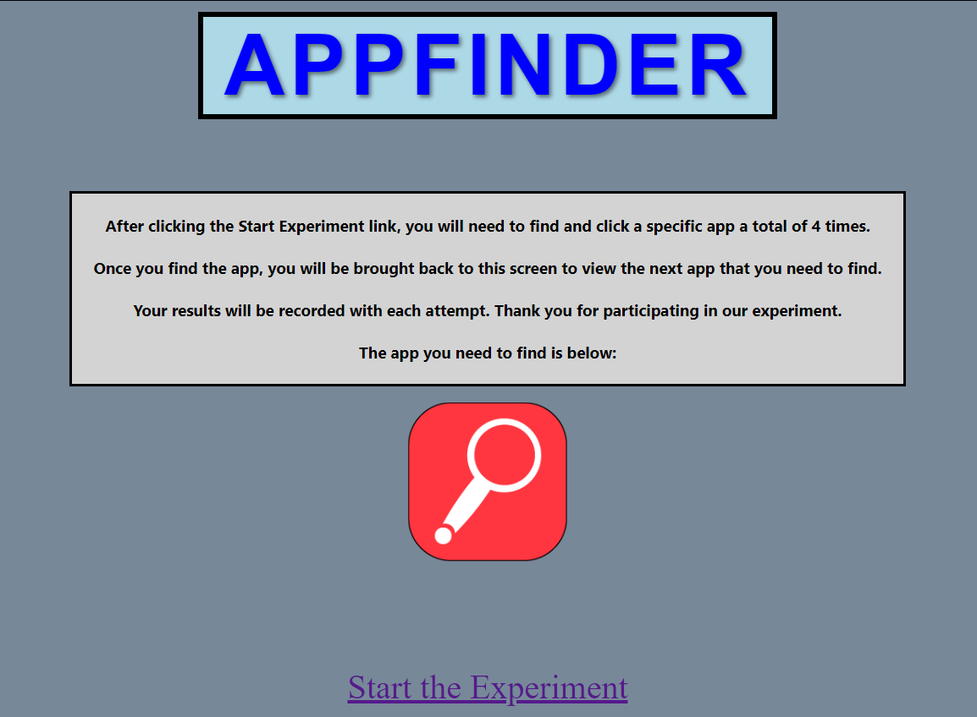

Figure 3 - Experiment homepage screenshot explaining to find the red target icon next.

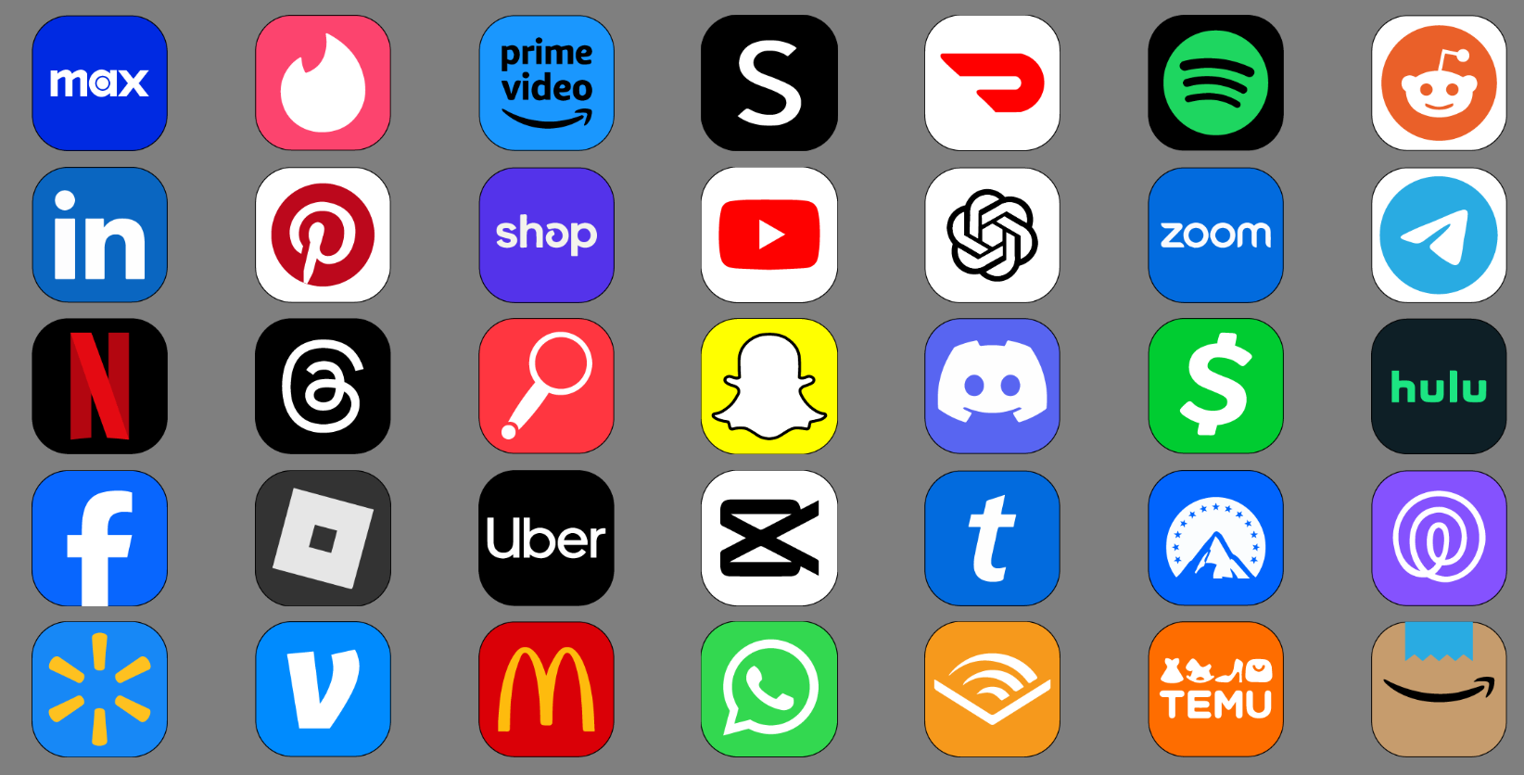

Figure 4 - Experiment search page screenshot where participant must click on the red target icon.

Participants for the experiment were chosen based on availability as well as excluding members of the community who are colorblind. The reason for this is because the experiment was a color based experiment and if a user was color blind then they would not be able to complete the experiment properly. After users signed a digital consent form, they were brought to a room with two computers with the experiment running on both. They were permitted to choose between the two of them. A Macbook and a Thinkpad were used in this experiment with both machines running at 1080p and the screens being roughly 13-14 inches in size. After sitting down, the instructor would give a brief explanation of the experiment and then have them read the small instruction set on the homepage of the experiment. Once the participant was comfortable with the instructions they would start the experiment and no questions would be answered while the experiment was being administered. Once the experiment was complete, participants were thanked for their time and their responses were recorded in a text file on the individual computers.

RESULTS

The results of the experiment were collected from text files containing the data of each round of the experiment which was downloaded after a user completed all four tasks. The text files for all participants were placed in a spreadsheet and then analyzed to determine if any outliers existed. One was removed from the dataset because it was the only test where misclicks occurred, which impacted the time taken for the red test because it was around 3 standard deviations above the mean. Two others were removed from the analysis because they were at minimum 15 standard deviations above the mean, either due to distraction, starting the experiment early, or any other possible cause. By this point, a total of 21 participants were recorded but only 18 used in the data analysis. This was done by utilizing an analysis of variance (ANOVA) to search for statistical significance using the sum of the times, also known as the aggregate. The ANOVA of the aggregate is displayed in the image as well as the table below.

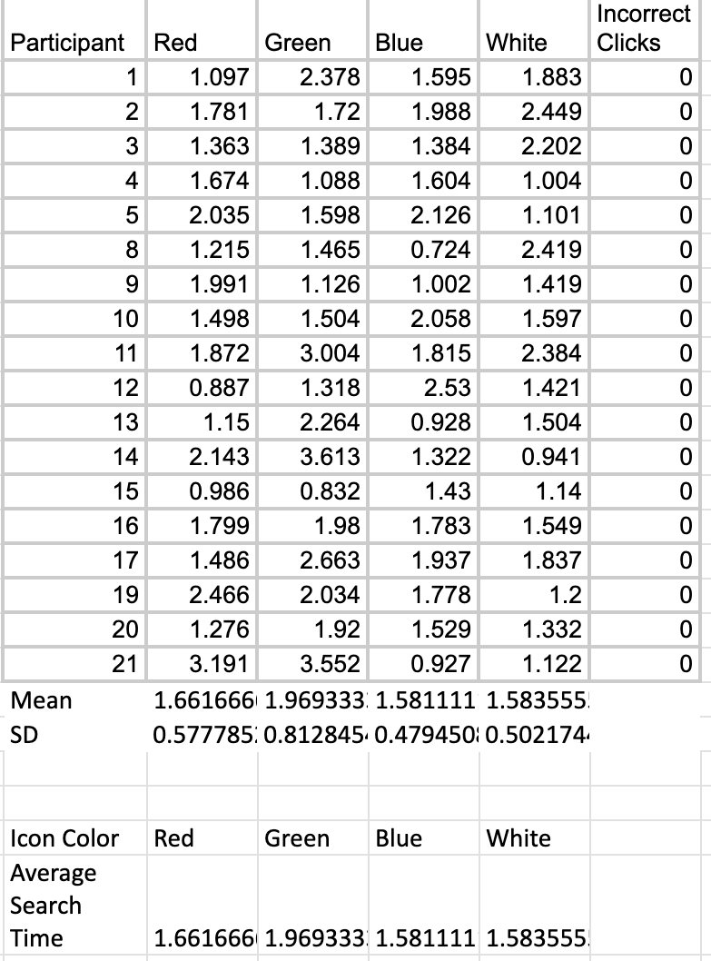

Figure 5 - Experiment Data Collected without Outliers

The statistics most relevant to determining if the data shows significance or not in regards to the hypothesis are the F-value and p-value. If F > 1.0 and p < .05, then the data is considered significant. As shown in the table below, the F-value was indeed greater than 1.0, but the p-value was 0.185, meaning that the data collected did not have much significance. Because of this, the hypothesis that the color of an app affects how fast it can be located cannot be rejected nor proven to be true according to this experiment.

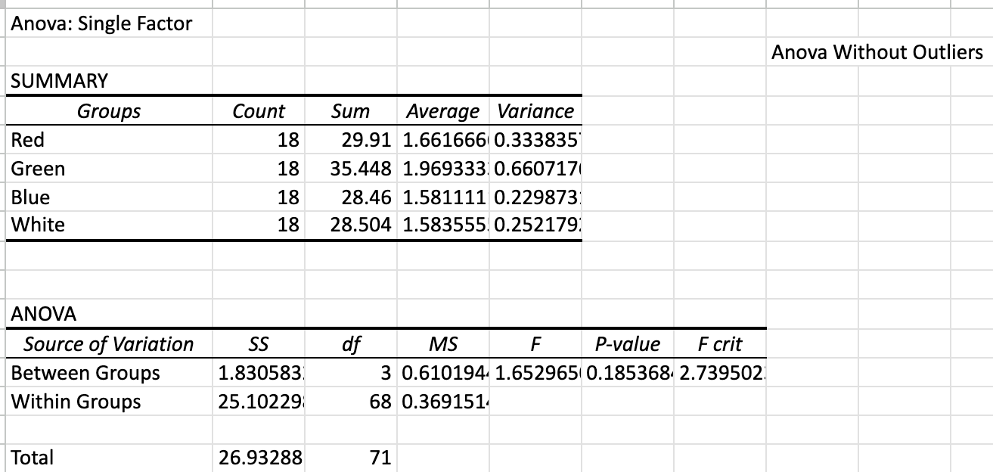

Figure 6 - ANOVA data and summary

DISCUSSION

Because the data collected from this experiment equates to the results being statistically insignificant, it may be determined that the color of an app has no effect on the rate at which it is located. The figures above display the full details of the results as well as the calculations done to determine the significance of the statistics, but there are more things to consider than just proving or disproving the null hypothesis presented based on the small pool of participants. Numerous factors could have influenced the data collected. The randomized location of an app could influence the speed at which it was located. If the app appeared in the center of the screen, it could have been found faster because of the participant’s eye naturally focusing on the middle of the webpage. A corner position could also take longer for the participant to mouse over regardless of the speed in which they located it with their eyes.

The business of the background of the home screen could have also affected the time for each round. The group chose a plain gray background so as to minimize the level of distraction participants experienced, however it is uncommon for people to have plain wallpapers. Having a busier background or selecting a different color could have more accurately simulated a person’s home screen, which may have provided different results than the ones from this experiment. The simple background was chosen to minimize variables that could affect a participant’s reaction time, but this choice could have been detrimental to having an accurate simulation.

Similarly, had this experiment been done on a phone as it is meant to mimic locating an app on a home screen, the use of a touchscreen could have warranted very different results in regards to the speed and accuracy at which a participant could click on a specific app. Because both laptops used in this experiment were done with a screen resolution of 1080p and had trackpads rather than a mouse, these physical limitations could have changed the outcome of each participant’s reaction time. Those more familiar with a mouse might have had a more difficult time swiping the trackpad fast enough, and those who were more comfortable with a trackpad might have possessed an advantage and skewed the results.

Regardless of the uncontrollable variables that could have influenced the results collected, there are still interesting data points to look closer at. For example, the times for green when compared to other colors were higher despite the insignificance of the overall dataset. The average time recorded for green was approximately 24% longer compared to the average of the colors white and blue. The graph below shows the average time as well as the standard deviations for each color. When considering the fact that a majority of the miscellaneous distraction apps (about 40%) chosen to populate the display were blue, it is surprising that blue had the fastest reaction time rather than any of the other three colors that would have theoretically stuck out more. The second fastest time was the white icon, and the second most common app colors for distraction apps were black and white.

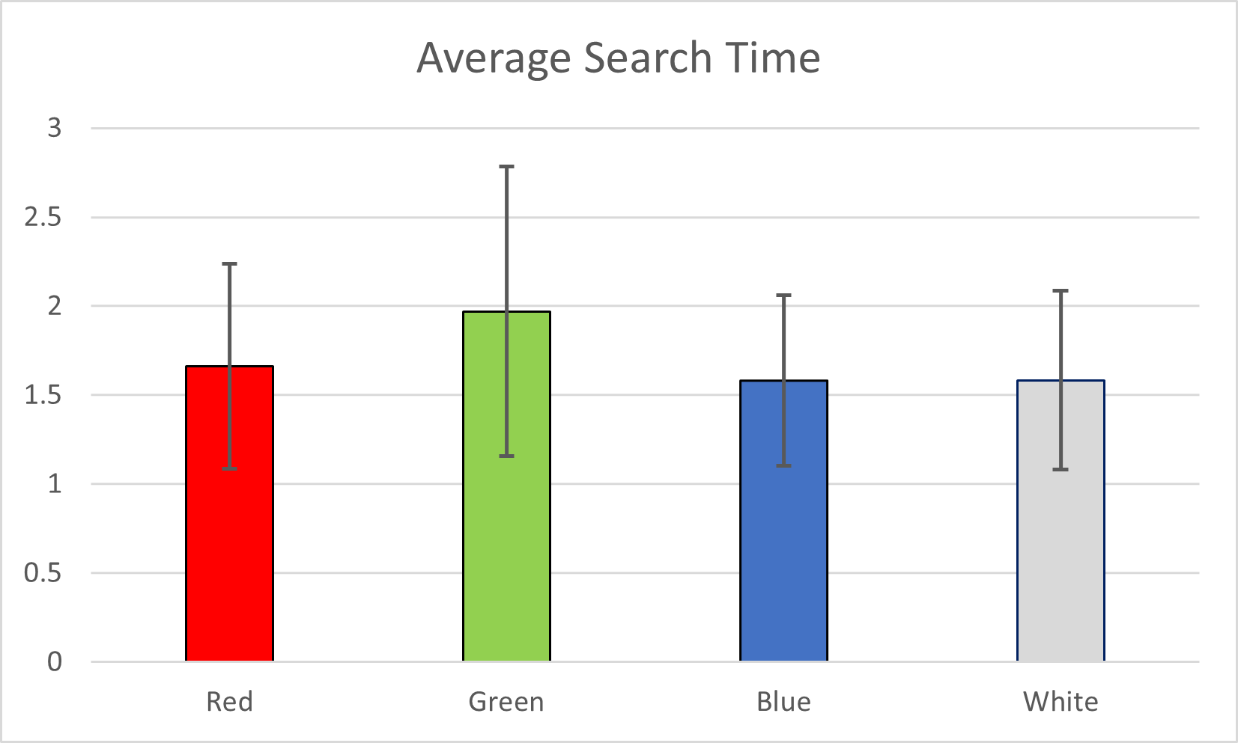

Figure 7 - Graph of Color Means and Standard Deviations

Although the statistical analyses did not reveal significant differences in the speed of app location across the four differing color variations, the qualitative dimensions of participant interactions can still merit consideration. Some verbal feedback from participants highlighted the fact that color didn’t play a significant role in how they located the app and instead they focused on the shape of the magnifying glass icon chosen. Other participants mentioned that the black outline of the magnifying glass of the white icon stood out more than the white it was given for the three other colors. These factors could have all played a role in how participants recognized and reacted to the icon’s randomized location.

CONCLUSION

Based on the results of this experiment, the color of an app has little to no significance in how recognizable it is and thus how fast it can be located amongst a cluttered home screen. Even if the experiment did not show statistical significance based on the ANOVA tests, it contributed to the cumulative knowledge in the field of human-computer interaction. Experiments such as this one that seemingly yield insignificant results still add to the broader context of understanding user behavior and preferences, and can also be repeated and yield different results based on the variety and number of participants. Understanding the nuances of user behavior in response to color-coded interfaces can contribute valuable qualitative data, shedding light on potential trends, user preferences, and navigational challenges. Future works could be conducted and expand upon the color-reaction time theories tested in this experiment, and new discoveries can be made.

Works Cited

[1] Goonetilleke, Ravindra S., Shih, Heloisa M., On, Hung K., and Fritsch, J. (2001). Effects of Training and Representational Characteristics in Icon Design. *International Journal of Human Computer Studies, 55* (5), 741-760. <https://doi.org/10.1006/ijhc.2001.0501>

[2] Kamarulzaman, Nor A., Fabil, N., Zaki, Z., and Ismail, R. (2020). Comparative Study of Icon Design for Mobile Application. *Journal of Physics: Conference Series, 1551*. 10.1088/1742-6596/1551/1/012007.

[3] Liu, W., Cao, Y., and Proctor, R. (2021). How Do App Icon Color and Border Shape Influence Visual Search Efficiency and User Experience? Evidence from an Eye Tracking Study. *International Journal of Industrial Ergonomics, 84*. <https://doi.org/10.1016/j.ergon.2021.103160>.

[4] Trapp, Anna K., and Wienrich, C. (2018). App Icon Similarity and its Impact on Visual Search Efficiency on Mobile Touch Devices. *Cognitive Research: Principles and Implications, 3* (3). <https://doi.org/10.1186/s41235-018-0133-49>.

[5] Shneiderman, B. (1984, September). *Response time and display rate in human performance with computers*. https://www.cs.umd.edu/.

[6] Hübsch, A. (2016b, January). *Proceedings of Ume˚a’s 20th Student Conference in Computing Science*. Can a High Color Contrast Touch Interface Increase User Reaction Time when Using a Smartphone Web Based Application?

[7] Sarikaya, A., Correll, M., Bartram, L., Tory, M., & Fisher, D. (2019). What Do We Talk About When We Talk About Dashboards? IEEE Transactions on Visualization & Computer Graphics, 25(1), 682-692. <https://www-computer-org.cobalt.champlain.edu/csdl/journal/tg/2019/01/08443395/17D45XDIXWb>

[8] MacKenzie, I. S. (2013). Human-Computer Interaction: An Empirical Research Perspective. Morgan Kaufmann.

[9] Balakrishnan, G., Uppinakudru, G., Sing,h G., Bangera, S., Raghavendra, A., Thangavel D. (2014). A Comparative Study on Visual Choice Reaction Time for Different Colors in Females. Neurology Research International, U.S. National Library of Medicine. [www.ncbi.nlm.nih.gov/pmc/articles/PMC4280496/](http://www.ncbi.nlm.nih.gov/pmc/articles/PMC4280496/).

[10] Nguyen, Ta., Vu, P., Pham, H., Nguyen, Tu., (2018). Deep Learning UI Design Patterns of Mobile Apps. 2018 IEEE/ACM 40th International Conference on Software Engineering: New Ideas and Emerging Technologies Results. <https://www-computer-org.cobalt.champlain.edu/csdl/proceedings-article/icse-nier/2018/566201a065/13bd1ftOBCq>